# Week 08: Coursework

## Spring Framework

1. Fork and clone the following Github repository.

<https://github.com/busyQA-java-developer/busyqa-08-spring-3-coursework-initial.git>

1. Import the Gradle project into Eclipse.
2. This project is a small web application based on the busyqa-08-spring-2-course-complete project that we coded in class. This application adds the Role property to the User. We have three roles: Admin, User and Guest, but a User can have one role only. The Users’ and Roles’ information is stored in a MySQL database.

We added the *Role* column to the *Users’ Table in the picture above*.

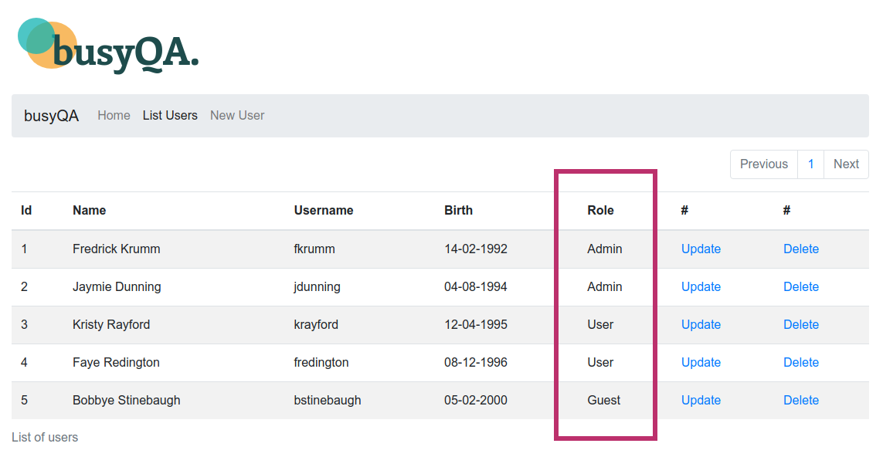

The *New User* form has a new field to select the *Role* from a dropdown box in the following picture. The *Update User* form has a new field to choose the *Role*.

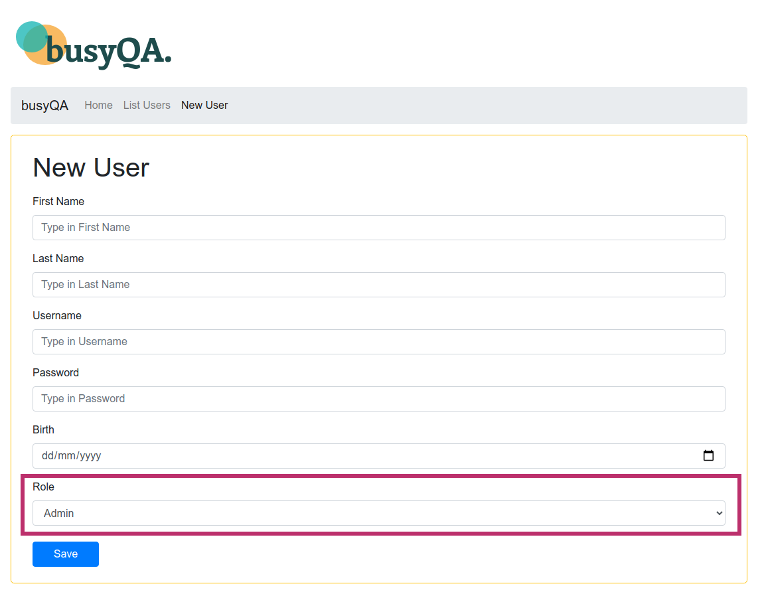Please check the User, UserRole and the Role entities in the JPA package of the project. Note that the User class has a UserRole List property. Also, note that UserRole has a User and a Role property.

**Note.-** This project uses four Thymeleaf HTML templates. These templates require no modifications unless you want to customize them. However, the UserController and the UserService need some coding. The changes are detailed inside the UserController from A to F and the UserService from G to J. You can use the busyqa-08-spring-2-course-complete project that we coded in class as a reference.

1. After completing the project, test it, commit and push your changes to your GitHub repository.
2. You can find the solution for the project in the Github repo:

<https://github.com/busyQA-java-developer/busyqa-08-spring-4-coursework-complete.git>

// End